Accenture Operations Twin
DTA- Expert Knowledge
ARCHITECTURE AND IMPLEMENTATION
Release Version: 2.5

Metadata Table
Field | Value
Asset / Solution Name | Accenture Operations Twin / AOT
Domain / Area | Digital Twin / Architecture
Owner (Team/Person) | Tournier, Florian
Reviewers | Horodinca, Florin and Takó, István
Status | Draft / In Progress
Confidentiality | Internal / Confidential
Source of Truth | Summary - Overview
Related Assets / Alternatives


Contents
Introduction 3
Purpose 3
Target Audience 3
Business Contacts 3
Technical Contacts 3
Prerequisites 3
Cloud Resources 3
Deployment 3
Related Links 3
Glossary 3
Expert Knowledge Submission Architecture 4
Validation Agent Workflow 5
Reviewer workflow- Approve/Reject 7
Recommendation Generation 8

Introduction

Accenture Operations Twin (AOT) is a collection of software accelerators and tools, including Digital Twin Assistant, that can be assembled to deliver client solutions. AOT accelerates the integration of product, process, and live data from disparate IT and OT systems, creating a comprehensive and contextualized view of operations to enable better decisions and optimized processes.
Expert Knowledge is a functionality of the Digital Twin Assistant (DTA) designed to capture and preserve knowledge about the suggestions and actions taken to resolve various issues. This enables the system to provide relevant recommendations, assisting users in effectively addressing similar issues in future.

Purpose
This document explains the architecture and integration of the Expert Knowledge framework within the AOT application. It outlines how expert insights are captured, validated using AI-generated scores and utilized for recommendation as part of AOT's Generative AI recommendation framework.

Target Audience
Software architects, developers, and integrators with IT backgrounds.

Business Contacts
- florian.tournier@accenture.com
- judit-kinga.zoltani@accenture.com

Technical Contacts
- florin.horodinca@accenture.com

Prerequisites
- Python 3.10
- Install the libraries provided in requirements file from the repository
- Azure Repository Access

Cloud Resources
Resource | Function
Azure OpenAI | LLM models used are gpt-4o, text-embedding-3-small
Azure Cosmos DB: | Collections created are graphql_queries(to store query and question mapping), user_chat_history(to store context history)
AI Search: | A vector database to store the embeddings of the unstructured documents (with semantic-ranker enabled)
Storage account: | A container to store the queries and unstructured docs.
Function app: | A HTTP trigger-based function to facilitate the ingestion of queries to cosmos and unstructured docs to AI Search (whenever required)
Kubernetes Service: | To deploy the GenAI Implementation API

Deployment
The docker file and the CI/CD pipeline are available in AOT's-Azure repo. The resource group APIs and connection strings in the pipeline variable group library must be updated before deploying to the environment.

Related Links
- Data processing Repo
- GenAI API Repo

Glossary
Term | Definition
Function App | A serverless compute service that enables running event-triggered code, such as processing HTTP requests for data ingestion.
Kubernetes Service | A platform for deploying, scaling, and managing containerized applications, used here for GenAI Implementation API.
Docker File | A text document containing instructions to build a Docker container image for application deployment.
CI/CD Pipeline | Automated processes for continuous integration and delivery, facilitating code building, testing, and deployment.
Cosmos DB | A globally distributed NoSQL database service used for storing application data such as insights and submissions.
Blob Storage | Azure's object storage solution for storing unstructured data, such as uploaded images.
Expert Knowledge | Information submitted by users detailing how an insight was resolved, often linked with recommendations and supporting data.
Insight | An actionable observation or recommendation generated by the system, which may trigger expert knowledge submission upon closure.
Validation Agent | An automated system that assesses the submitted expert knowledge for parameters like toxicity and clarity.
GenAI API | An interface for interacting with generative AI models, typically deployed via Kubernetes Service in this architecture.

Submission

Expert knowledge can be submitted when a user closes an Insight. At that moment, a new tab appears where a Title can be provided together with the details of how that insight was resolved. Additionally, an image can be uploaded to enhance the information.
The expert knowledge data is linked to Insight template based on these keys:
- Type
- Theme
- Sub-type
- PlantId
When a recommendation is generated, it will be stored on the expert knowledge object, meaning it will be available for all insights belonging to the same template.
The following diagram shows this flow:

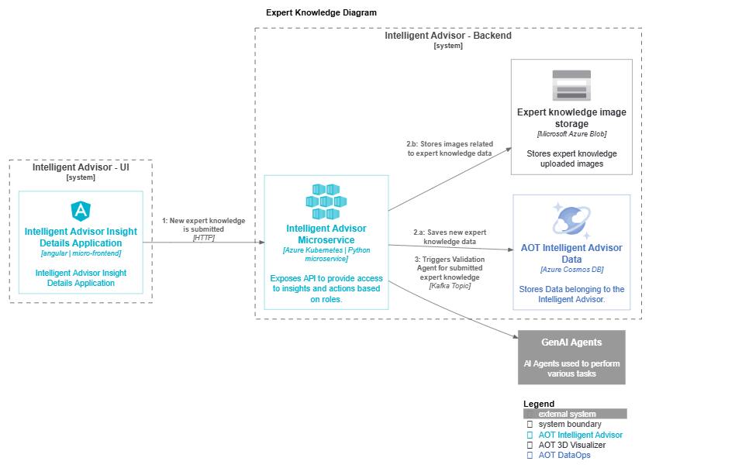

Validation

Agent Workflow

Once the user submits the knowledge from Intelligent Advisor Details Application, the information is saved in Intelligent Advisor database (Cosmos DB) in a draft state. If an image has been provided, it is stored in blob storage. At that moment, the submitted information must be validated by the validation agent, which will return a scoring result for each of these parameters:
- Toxicity
- Clarity
- Professionalism
- Action-Oriented
To do this, IA microservice will generate a message on a Kafka topic with the necessary information that needs to be validated, and the GenAI microservice will take it and invoke the Validation Agent. The message received contains information needed to identify the sender service so that the result can be sent to the right one. The agent will take the information received and will validate it. If any image is provided, it will generate a brief description of it.
The Expert Knowledge Validation Agent is instructed to return the response in a JSON object format that has these fields:

{
'clarity': {
'value': 'X/5',
'description': 'xyz'
},
'professionalism': {
'value': 'X/5',
'description': 'xyz'
},
'action_oriented': {
'value': 'X/5',
'description': 'xyz'
},
'toxicity': {
'value': 'X/1',
'description': 'xyz'
},
'summary': 'xyz',
'error': ''
}

The error field will contain a description of the errors encountered during validation (i.e. the image description could not be generated).

Once the agent finishes the validation, the result will be sent back to the Kafka topic and IA microservice will pick it up and update the relevant Expert Knowledge with the score data and will also put it in "Pending" state. This means the data is ready to be reviewed by a reviewer person.
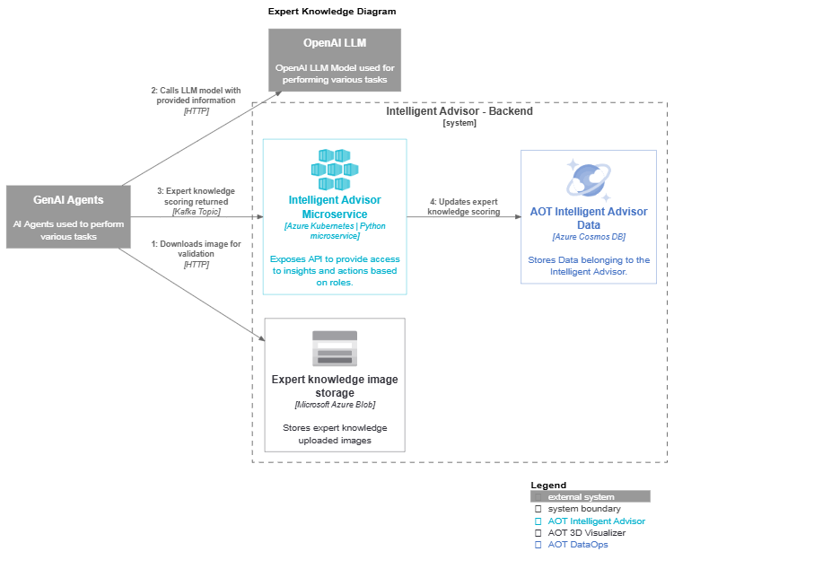

Review

Human Reviewer Workflow
The review can be done in a new application dedicated for reviewing Expert Knowledge. The user can see all the information that was submitted along with the validation result from the agent. It will then decide if all the information is relevant and can be used to solve the issues and will act on it: it will approve or reject the expert knowledge. The following diagram shows this process:
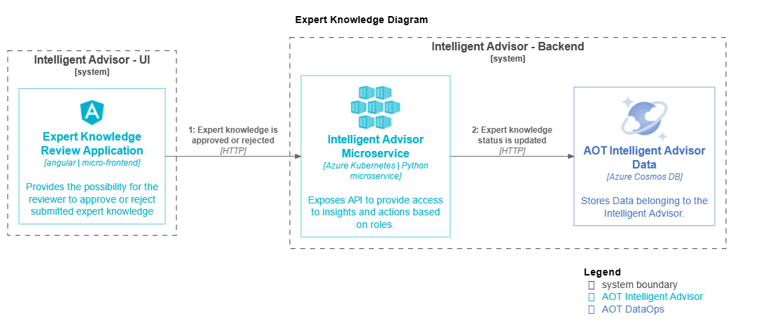

Recommendations

The captured and validated expert knowledge can be used to generate recommendation for Insights belonging to the same template of which it was captured. This can be done through the Insight details application/window, or through the Digital Twin Assistant when information about the isights is requested. The flow can be seen in the following diagram:
Once the user clicks on the button to generate recommendation, the IA service will send a kafka message with required information to GenAI microservice. It is instructed to rely only on the provided information to generate a recommendation which will be sent back to IA microservice through kafka topic, where it will be saved on the expert knowledge object.

